2005 Felton Road Pinot Noir Block 3

Viticulture
Meticulous summer management of a single vertical shoot positioned (VSP) canopy ensures even and early fruit maturity. Shoot thinning, shoot positioning, leaf plucking, bunch thinning and harvest are all carried out by hand to ensure optimum quality fruit. Cover crops are planted between rows to assist in controlling vine vigour and to improve soil health and general biodiversity. All of our vineyards are managed organically and also utilise biodynamic practices throughout.
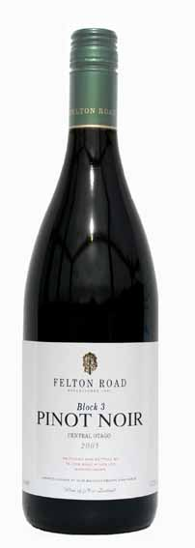

Vintage & Vinification
Detailed observations from the various vineyard blocks (and even within blocks), enable small parcels to be kept separate and handled appropriately in the winery. 80% destemmed with no crushing and 20% as whole clusters provide an extra layer of complexity and brings an apparent sweetness to the mid-palate. Drained by gravity from the fermenter directly to the underground cellar and aged for 11 months in 55% new French oak. In accordance with our non-interventionalist approach to winemaking, this wine has not been racked, fined or filtered.

Bouquet & Palate
The purity is overwhelming: forget counterpoint and diversity, this is a single-minded descent into dark silk and sensual richness. Everything about this wine is dark: the earth and rich spice of the nose, the extraordinary way the mouth is enrobed in dark, dark fruits. The wine is completely seamless: harmonious, with a plush viscosity, like falling into blackberry flavoured silk cushions. The tannin is dense but too fine to feel the structure. An immersion into hedonis!

Wine Spectator Insider, USA. February 8, 2006

2004 Pinot Noir Block 3. Felton Road's Pinots are among the most collectible
in New Zealand. This one is bright and lively, with a sweet pomegranate note weaving through the polished blackberry and cherry flavours, lingering on the smooth finish. Balanced, with fine acidity. Drink now through 2012.-H.S.

