2004 Felton Road Pinot Noir Block 5

Viticulture
Meticulous summer management of a single vertical shoot positioned (VSP) canopy ensures even and early fruit maturity. Shoot thinning, shoot positioning, leaf plucking, bunch thinning and harvest are all carried out by hand to ensure optimum quality fruit. Cover crops are planted between rows to assist in controlling vine vigour and to improve soil health and general biodiversity. All of our vineyards are managed organically and also utilise biodynamic practices throughout.
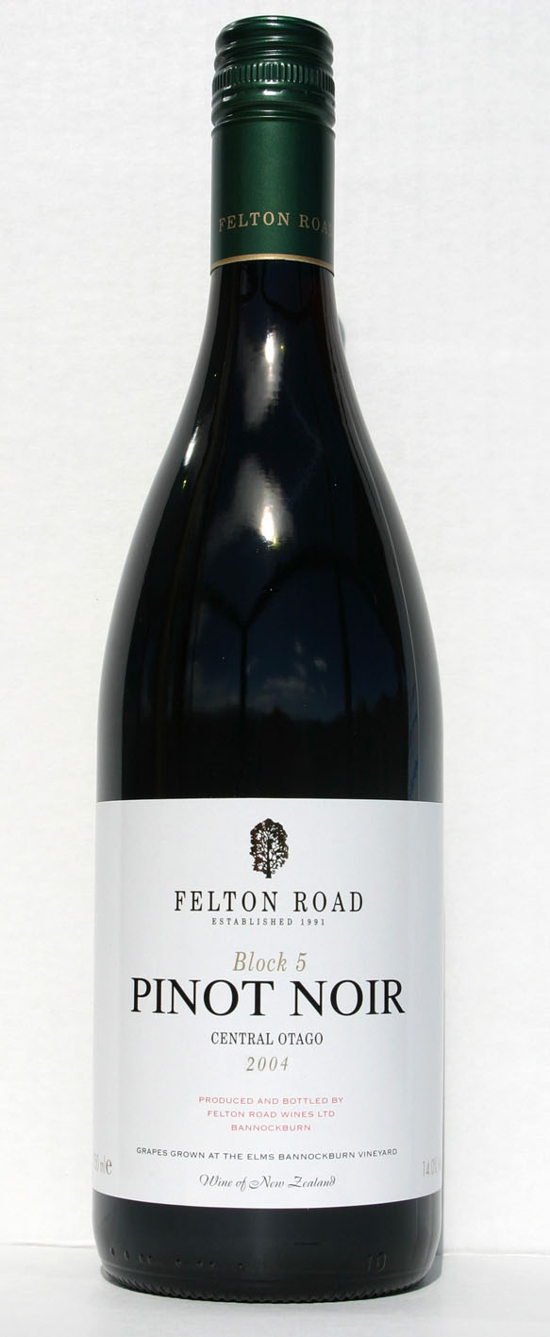

Vintage & Vinification
The unique gravity flow winery enabled the grapes to be gently destemmed directly into open-top fermenters without pumping. Traditional fermentation with a moderately long maceration on skins has extracted good colour and tannin with considerable depth of flavour. This wine was aged for 18 months in French oak barrels from highly regarded Burgundian coopers. In accordance with our non-interventionalist approach to winemaking, this wine has not been fined or filtered.

Bouquet & Palate
A rich spectrum of aromas include black plums, ripe cherry and exotic spice. Sweet dark fruits lend an opulent decadence to a well refined palate. Subtle and well integrated oak supports the fine grained and lengthy finish, offering excellent cellaring potential.

Matthew Jukes, March 2005 expertwine.com
2003 Felton Road Pinot Noir Block 5
While this wine is tighter and certainly more mineral than Block 3, it is also starting to get some self-confidence and grooming as well as its staggering intellect. This is a challenging wine, but it is starting to give as well as take and that makes for a very attractive combination.”

