2006 Felton Road Riesling

Viticulture
Meticulous summer management of a single vertical shoot positioned (VSP) canopy ensures even and early fruit maturity. Shoot thinning, shoot positioning, leaf plucking, bunch thinning and harvest are all carried out by hand to ensure optimum quality fruit. Cover crops are planted between rows to assist in controlling vine vigour and to improve soil health and general biodiversity. All of our vineyards are managed organically and also utilize biodynamic practices throughout.
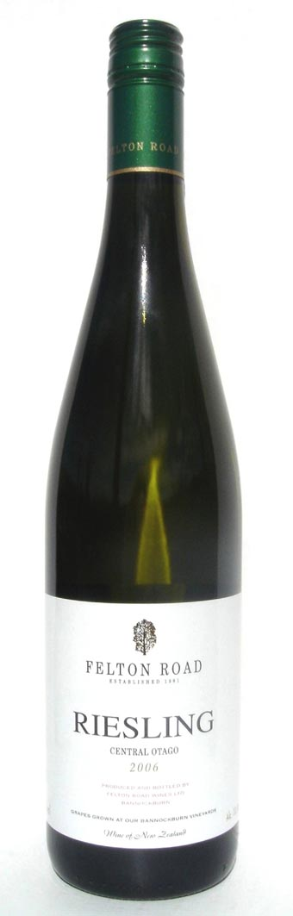

Vintage & Vinification
Riesling from Blocks 2 and 4 (Elms Vineyard) and Calvert Vineyard (just 1km along Felton Road), was carefully hand harvested from mid to late March. This early harvest resulted from the warm spring and summer and was necessary to retain the bright Riesling aromas and flavours and our hallmark crisp natural acidity. The grapes were whole bunch pressed followed by a wild fermentation (uninnoculated). Careful winemaking with minimal processing preserves the delicate Riesling characters. The fermentation was stopped by chilling the wine and racking off the yeast lees at the desired sugar/acid balance.

Bouquet & Palate
Ripe tropical fruit leading into stonefruits on the nose are complimented with our typical mineral and spice notes. Intense stonefruit flavours (nectarine and blackboy peach) integrate seamlessly with the residual sugar of 50 g/L. The considerable initial sweetness on the palate, low alcohol of 10.5% and high natural acidity, all combine to contribute to the wine’s precise and intricate balance. A wine that will richly reward cellaring of up to 10 years and beyond.

2005 Felton Road Riesling
“It is so beautifully judged, a delicate tri-partite balance between relatively high residual sugar (48 grams), high natural acidity and an alcohol level of just 9.0%. The end result is a wine of luscious citrus and tropical flavours, but with an almost floral lightness and precise, complementary acidity.” Matthew Jukes, March 2006, expertwine.com

